There the five types of inheritance as below

1. Single inheritance
2. Multilevel inheritance
3. Hierarchical inheritance
4. Multiple inheritance
5. Hybrid inheritance
6. **Simple or Single inheritance**

In this only one super class and only one sub class called as single.

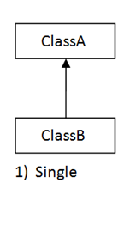

**package** com.inheritance;

**public** **class** Insurance {

**void** getInsuranceDetails() {

System.***out***.println("this is insurance details..");

}

}

**package** com.inheritance;

**public** **class** HealthInsurance **extends** Insurance {

**void** getHealthInsuranceDetails() {

System.***out***.println("this is health insurance details.");

}

}

**package** com.inheritance;

**public** **class** TestMain {

**public** **static** **void** main(String[] args) {

HealthInsurance healthInsurance = **new** HealthInsurance();

healthInsurance.getInsuranceDetails();

healthInsurance.getHealthInsuranceDetails();

}

}

Output

this is insurance details..

this is health insurance details.

1. **Multilevel inheritance**

It has only one base class and multiple derived class called as multilevel. Or it refers to the concept of one class extending (Or inherits) more than one base class.

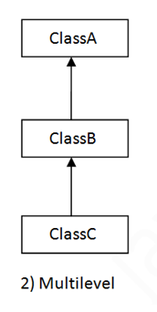

**package** com.inheritance;

**public** **class** Account {

**void** getAccountDetails() {

System.***out***.println("this is account details..");

}

}

**package** com.inheritance;

**public** **class** CurrentAccount **extends** Account {

**void** getCurrentAccountDetails() {

System.***out***.println("this is current account details");

}

}

**package** com.inheritance;

**public** **class** SavingAccount **extends** CurrentAccount {

**void** getSavingAccountDetails() {

System.***out***.println("this is saving account details");

}

}

**package** com.inheritance;

**public** **class** TestMain {

**public** **static** **void** main(String[] args) {

SavingAccount savingAccount = **new** SavingAccount();

savingAccount.getAccountDetails();

savingAccount.getCurrentAccountDetails();

savingAccount.getSavingAccountDetails();

}

}

Output

this is account details..

this is current account details

this is saving account details

1. **Hierarchical inheritance**

One class is inherited by many sub classes called as.

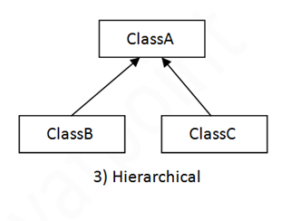

**package** com.inheritance;

**public** **class** Loan {

**void** getLoanDetails() {

System.***out***.println("this is loan details");

}

}

**package** com.inheritance;

**public** **class** HomeLoan **extends** Loan {

**void** getHomeLoanDetails() {

System.***out***.println("this is home loan details..");

}

}

**package** com.inheritance;

**public** **class** PersonalLoan **extends** Loan {

**void** getPersonalLoanDetails() {

System.***out***.println("this is personal loan details");

}

}

**package** com.inheritance;

**public** **class** CarLoan **extends** Loan {

**void** getCarLoanDetails() {

System.***out***.println("this is car loan details.");

}

}

**package** com.inheritance;

**public** **class** TestMain {

**public** **static** **void** main(String[] args) {

HomeLoan homeLoan = **new** HomeLoan();

CarLoan carLoan = **new** CarLoan();

PersonalLoan personalLoan = **new** PersonalLoan();

homeLoan.getHomeLoanDetails();

carLoan.getCarLoanDetails();

personalLoan.getPersonalLoanDetails();

}

}

Output

this is home loan details..

this is car loan details.

this is personal loan details

1. **Multiple inheritance**

One class has many super classes called as multiple inheritance.

Why multiple inheritance not supported in java in case of classes?

Class base has test () method and class derived has also test () method. Class test extends Base, Derived, which test method It will called, so it create the ambiguity so that’s why multiple inheritance does not supports in java.

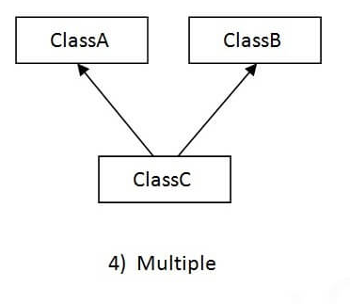

**package** com.multiple.inheritance;

**public** **class** A {

**void** m1() {

}

}

**package** com.multiple.inheritance;

**public** **class** B {

**void** m1() {

}

}

**package** com.multiple.inheritance;

**class** C **extends** A,B {

**public** **static** **void** main(String[] args) {

C c= **new** C();

c.m1();

}

}

Note- it will get the compile time error.

1. **Hybrid inheritance**

It is the combination of single and multiple inheritance. So it is not allowed in java.

